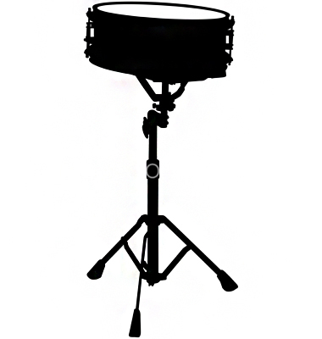
Mr. Glaser Challenges

Drummers

TO:

Challenge | COMPLETED!
Put drum together correctly and quickly. Adjust to correct height. Hold sticks correctly in both hands.
Listen to one famous drummer. Watch a Youtube video if you can. Tell Mr. Glaser the name and the song he/she played
Go to http://www.vicfirth.com/education/
Scroll down to Snare Drum and check out Beginning Snare Video Lessons and 40 Essential Snare Drum Rudiments
On Single Beat Combinations sheet play #1 at least 8 times in a row at 60 Beats Per Minute (1 beat for every second)
Get a metronome. Either an electronic one, a metronome app such as Metronomo (It’s free!) or online at metronomeonline.com (also free!)
Play the first 3 lines of Solo #1 Using alternating sticking. Play between 90-120 BPM. Use “Ta” to count quarter notes and rests and “Ti” to count 8th notes.
Play the Single Paradiddle using 16th notes. Play at least 8 times. Play at 60 BPM
Be able to play book exercises #1-23 with a correct posture, correct sticking, and correct rhythm
Play Multiple Bounce Roll (Buzz Roll) on quarter notes at 60 BPM.
Play Multiple Bounce Roll (Buzz Roll) on 8th notes at 60 BPM.

