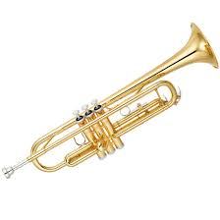
Mr. Glaser Challenges

Trumpets

TO:

Challenge | COMPLETED!
Hold Trumpet Correctly. Sit with correct posture.
Listen to one famous trumpet player. Tell Mr. Glaser the name and the song he/she played
Get a metronome. Either an electronic one, a metronome app such as Metronomo (It’s free!) or online at metronomeonline.com (also free!)
Play 4 quarter notes in a row on B, A, and G at 60 Beats per minute with out changing mouth placement. Use the tongue.
Play the G Major Scale in whole notes at 60 BPM
Play the G Major Scale in half notes at 60 BPM
Play the G Major Scale in quarter notes at 60 BPM
Be able to play book exercises #1-23 with a good tone, correct rhythm and correct notes
Play the G Blues Scale in whole notes at 60 BPM
Be able to play G, A, B, C, D in slurred quarter notes at 60 BPM

